Quarterly Newsletter - Goodbye to Summer

Blessed be the Lord, who daily bears us up; God is our salvation!
The Lord goes before us, he showers us with abundance,
restoring our inheritance and giving us a place to dwell.
Sing to God, sing praises to his name! Psalm 68

July 2025 Directors Summit Recap

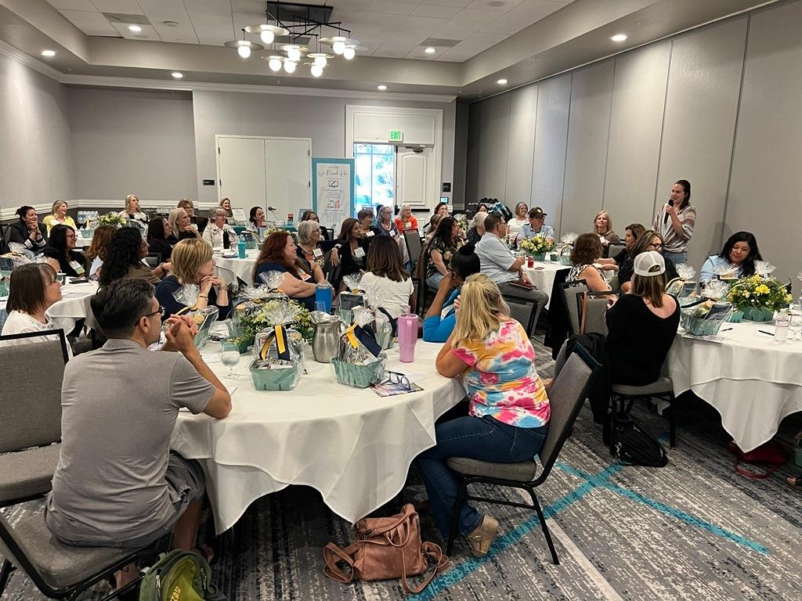
52 center directors gathered in San Rafael to worship, learn, laugh and pray; they came away encouraged and better prepared for whatever next comes their way.

Here are some of our fave quotes:

"I love CAPC, you guys rocked it!"

"Can't wait for the next one."

"Fellowship is always my favorite."
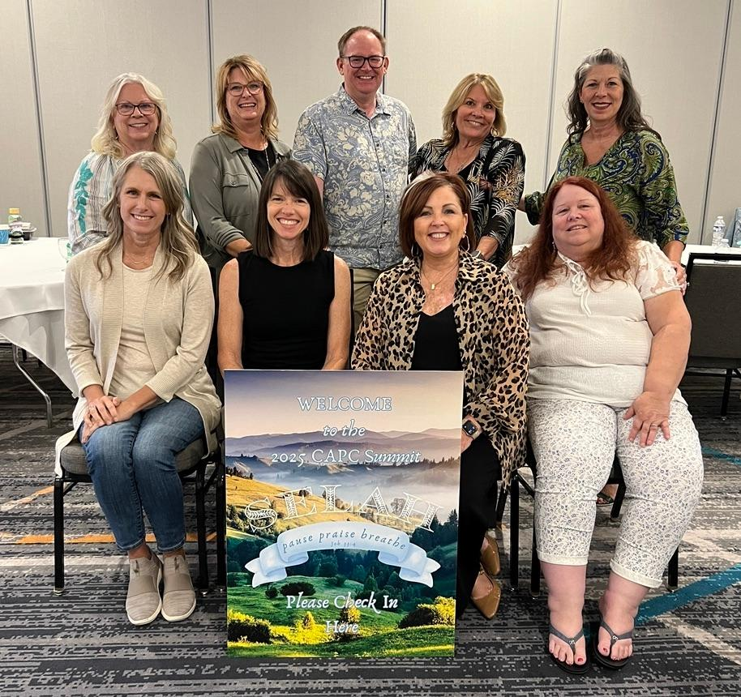
"It was amazing, keep up the great work, I am blessed & encouraged."

To view some of the great information shared during sessions at this year's Directors Summit, login to the member website here to view docs.

Directors Diary
﻿
Written by a different seasoned director each quarter.

From the Directors Summit, by Kathleen Jones
"Simple steps for us; the leaders God has called into the most rewarding, heart wrenching ministry..."
Read article here

Dr George Delgado, founder of Abortion Pill Reversal
Tammy Mahaney DNP of Real Options/Bella Primary Care
and Peter Breen, Executive VP of Thomas More Society
will be speaking in San Francisco for the

RESPECT LIFE CONFERENCE
Abortion pill: dangers, remedies, and legal challenges

Saturday, September 27
8:30am - 2:00pm

View flyer here

Many thanks to iRapture

iRapture partners with CAPC to offer our members website design, creative marketing ideas, help with Google grants and more, at cost effective rates with budget in mind. Visit their website or contact Jacob Barr to learn more.

Praying blessings on you,
Allison Martinez
Executive Director of CAPC
